1. **Find the count of nologin information from the /etc/passwd**

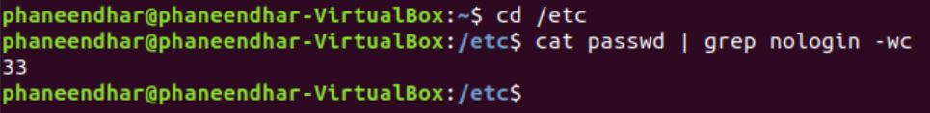

1. **List of all user names from /etc/passwd using the cut command**

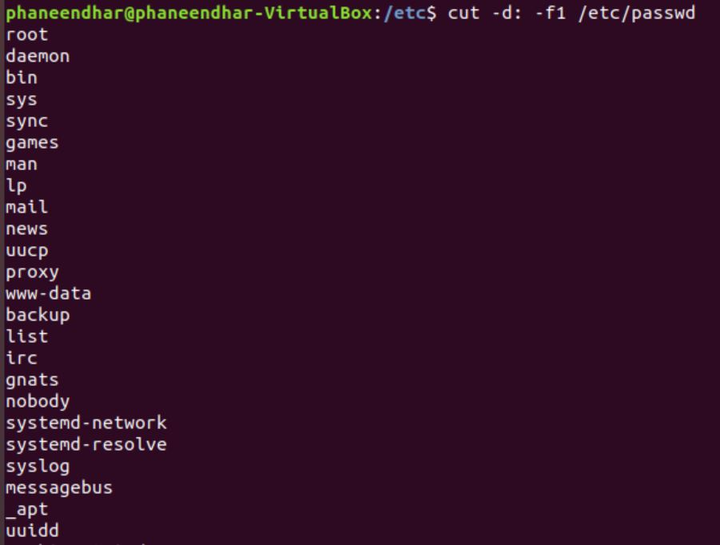

1. **Same as above but sort the results in reverse sorted order**

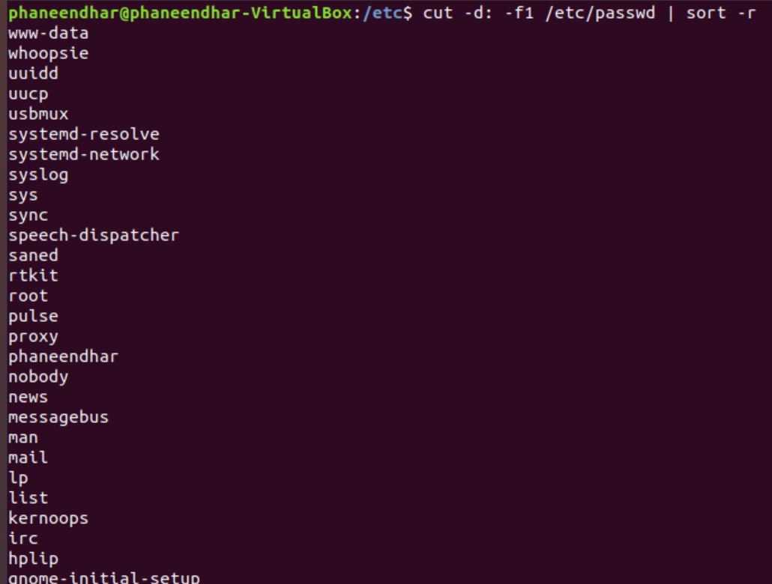

1. **Merge corresponding or subsequent lines of files.**

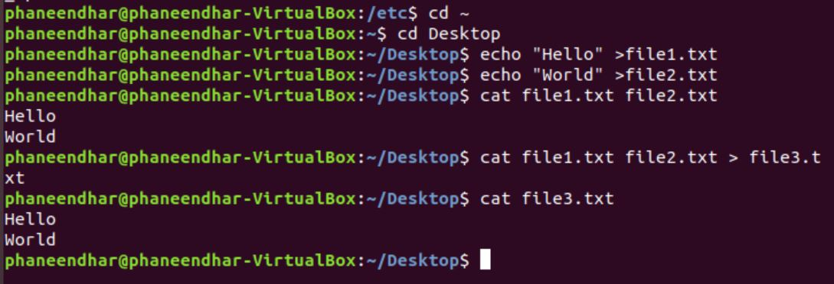

1. **How many types of shells are there in your system. (Use /etc/passwd information)**

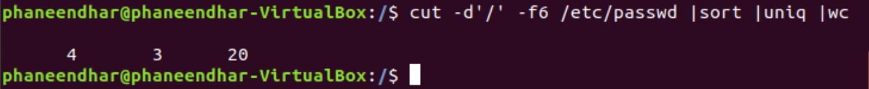

1. **Copy password file to your home directory without using the name of the home directory**

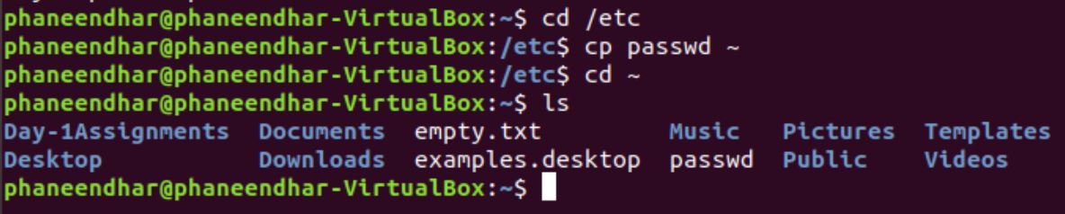

1. **How to find the present working directory**

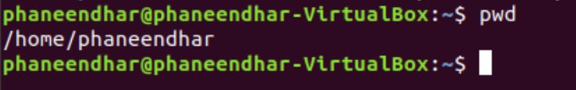

1. **Navigate to the home directory and List all the files in the home directory.**

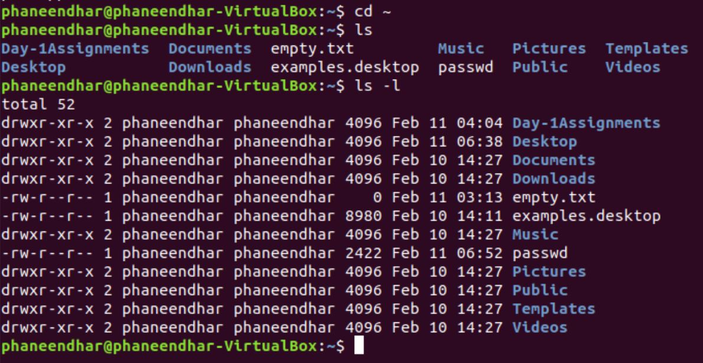

1. **Find out the meaning of the first column from the previous output.**

It is about the permissions given to a file or directory

d stands for directory

r stands for read permission

w stands for write permission

x stands for execute permission

1. **Observe the output and there are some files that have been listed in green colour and understand the meaning of it.**

Green colour indicates that the file or directory has all permissions like read, write, execute.

1. **Change the permissions of the file passwd that has been copied in the home folder.**

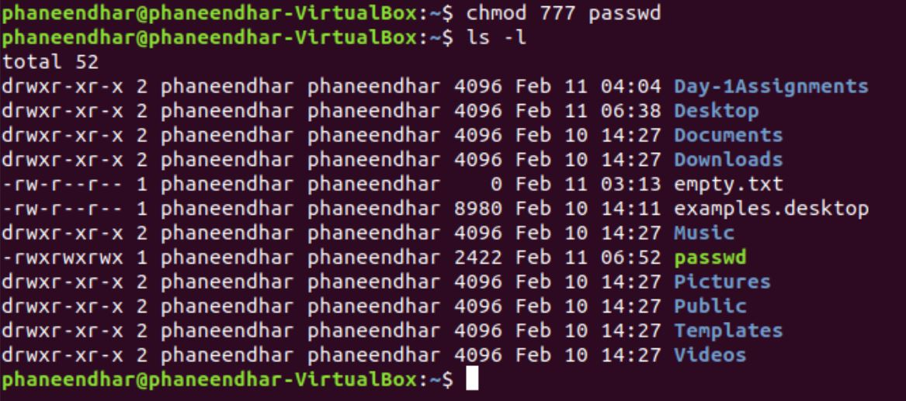

1. **Create a user for your friend and be careful about giving permissions**

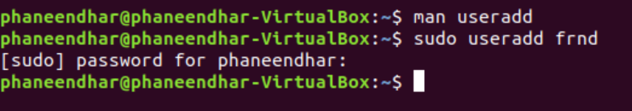

1. **Change the password of the newly created user.**

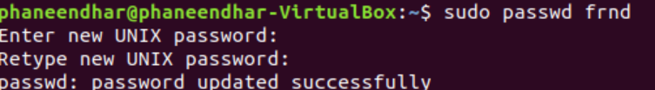

1. **Now ask your friend to login to his account from his machine.**
2. **Restart your system from the command line.**

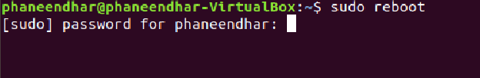

1. **Install the server on your machine for the users to login**
2. **Ask your friend to create a file in your machine.**
3. **Now, you have to block your friend to create files on your machine**